ENVIRONMENT SENSING USING SMART PHONE
AIM:
The main aim of this project is to design a system to monitor the parameters using Bluetooth technology.
- PURPOSE:
- The purpose of the project is to develop a system which is capable of sensing and automatic monitoring of various parameters in any sensitive things and it is useful in avoiding any damage or loss.

BLOCK DIAGRAM:

MICRO CONTROLLER AT89S52

POWER SUPPLY
LCD DISPLAY
(16 X 2 LINES)
BLUETOOTH MODULE
SENSORS
(LDR, TEMP, SMOKE)
ADC 0808
MAX 232

REMOTE UNIT:

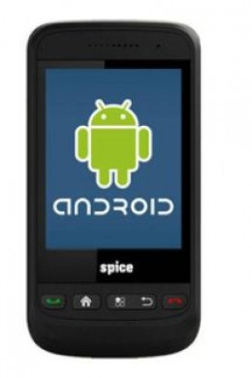

DESCRIPTION:

- This is a project based on Bluetooth and eliminates all cable requirements and it can be installed in very sensitive places. The main devices of this project are microcontroller board with all sensors (temp, LDR, fire etc) and Bluetooth Module.
- In this project we have developed the Bluetooth based data logger system using AT89S52 micro controller. In this system we have sensors (temperature, LDR, fire) connected to microcontroller. We use ADC to convert the analog values of sensors to digital for microcontroller. These sensors will continuously sense the data and gives this information to microcontroller. These values are continuously displayed and transmitted to the android mobile using Bluetooth module.
- This is very useful for the applications where data in very important and crucial. Applications of this project are many but few are residential access control, building security system, bank security system, industrial control applications, etc.
BLUETOOTH TECHNOLOGY:
Bluetooth was selected as our way of communicating PDA/Mobile with a central system. The reason Bluetooth was selected over Bluetooth for various reasons. First of all, Bluetooth security is less complex and more stable than that of Wi-Fi. Bluetooth manages a security measure of only permitting certain selected devices to interact with them; Wi-Fi in the other hand establishes a WEP key that has been known to be cracked. Another reason that Bluetooth was selected over Wi-Fi is that Bluetooth has a shorter range of signal emission than Wi-Fi. This is a pro because the shorter the range the less the amount intruders that will try to infiltrate your home system.
ANDROID:
Android is a software stack for mobile devices that includes an operating system, middleware and key applications. The Android SDK provides the tools and APIs necessary to begin developing applications on the Android platform using the Java programming language.

SOFTWARE REQUIREMENTS:

- Express PCB & Express Schematic.
- Kiel micro-vision
- Embedded C
- Android SDK

HARDWARE REQUIREMENTS:

- Microcontroller AT89S52.
- Bluetooth Modules.
- Temp, Humidity, Fire Sensors etc.
- LCD Display
- Power supply
- ADC

APPLICATIONS:

- Residential access control.
- Building security system.
- Bank security system.
- Industrial control applications.
- Status monitor.
- RESULT:
- By using this project, we can monitor and auto control the industrial equipments using Bluetooth technology.

